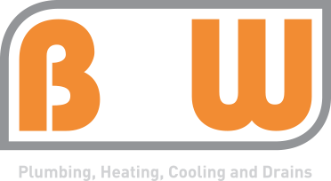
HVAC Service Tech
Job Description

Classification

Position Title: HVAC Service Tech
Average Annual Income: $40,000 - $80,000

Summary

The successful candidate will enjoy interacting with people and problem solving.

Responsibilities

- Troubleshoot HVAC/R equipment, indoor comfort, energy efficiency, and related problems
- Present findings and options to customers; provide advice and recommendations
- Provide customers with information on new equipment when repairs exceed remaining value of equipment and/or exisiting equipment exceeds 10 years of age.
- Provide customers with information and pricing on service agreements, accessories, quality, cost, and other comfort improvements
- Complete approved repairs, improvements, or installations within industry standard times, following proper safety procedures
- Collect for work performed
- Clean equipment and work area, ensure complete customer satisfaction upon completion of work
- Complete all paperwork/ electronic work order completions required by management
- Keep assigned service vehicle organized, clean, and stocked properly
- Perform other duties as assigned

Requirements

- Two or more years of experience as an HVAC installation, maintenance, or service technician or comparable education
- Ability to communicate clearly in a friendly, personable way with customers and coworkers
- EPA certified
- Valid social security card, driver’s license, and a clean driving record
- Well groomed, neat appearance. No facial hair. No visible tattoos or piercings.
- Able to quickly troubleshoot problems
- Strong attention to detail with a desire and ability to complete the job correctly the first time
- Understands and willing to follow proper safety techniques
- Ability to follow controls/wiring schematic
- Ability to braze/solder/weld
- On call over weekends and after hours as required
- NATE certification a plus

Physical Demands

To adequately perform the duties of this job the employee is regularly and routinely require to sit, stand, walk, stoop, use hands, use fingers, handle controls, hear, and talk. The employee is frequently required to reach with hands and arms. The employee must be able to climb ladders, work in hot and cold environments, and work in small crawl spaces. The employee must regularly lift and/or move up to 50 pounds. Specific vision abilities required by this job include close vision and the ability to adjust focus. Occasionally, the employee may be asked to drive long distances in performance of job duties. Our service area is Indianapolis and surrounding counties. The employee is required to frequently interact with other coworkers and customers.
Work Environment

The work environment noise level is usually moderate but will vary occasionally. The work environment will subject employees to continual interruptions and changing priorities. Effective, consistent, and constant communication with customers, vendors, co-workers, and others is required.

